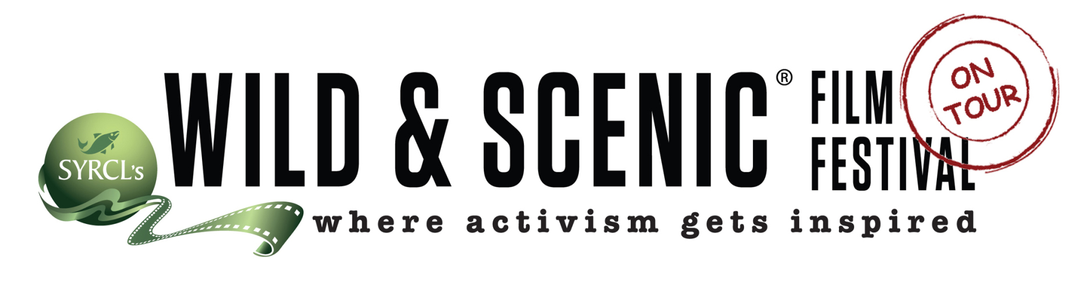

**Add-On Services**

(Make your program your own!)

**Video–on-Demand (Our most popular add-on!) = $299**

* We provide a password-protected link to your program open for 7 days, beginning the day of your event.
* This popular add-on allows hosts to share their program with those not in attendance.
* Can be ticketed or free. Used as a way to get new members or reach your entire community- not just the in-person crowd.
* VOD is charged for each individual event. (NOTE: Repeat Screenings are considered additional events for VOD.)

**Film Ingestions (add your content to your film program) = $200 per 20 minutes of ingestions**

* Total additional run time cannot exceed 20 minutes.
* Include up to 5 local short films, or a promo video for your organization and/or sponsor’s host clips.
* **Second Ingestion is an additional $200 ($400 total) for up to 20 additional minutes.**

**Feature-Length Film Screening = $500 each**

**(Add a feature film to your weekend event or another standalone event to be excited about later in the year.)**

* Feature Films available only to On Tour hosts with an existing custom or curated event contract.
* Feature Films must be screened within the same On Tour season as the primary On Tour event.

**Promotional Materials**

**Custom Trailer = $125**

* WSFF staff will add a customized slide to the end of the trailer with information about your organization’s On Tour event. *Please fill out the form located under Graphics.*
* You can post this customized trailer to your social media page and website!

**Custom Poster= $95**

* Graphic Design Services can be provided if you have no access to Adobe Creative Suite.
  + (For reference, posters and handbills typically take one hour total.)

**Additional Offers**

**Slide Packages:**

* Please note that 5 slides are included in your custom film program (Does not apply to curated film programs).
* **Premium Slide Package = $125**
  + Up to 5 additional custom slides OR 5 additional slide placements
* **Premium Plus Slide Package = $250**
  + Up to 10 additional custom slides OR 10 additional slide placements

**WSFF Banner Purchase = $100**

* Offer not applicable to sponsor banners.

**Captions**

* **Open Captions**= **$3** per minute + **$100** embedding fee
* **Closed Captions: $50**



**On Tour Fees**

**DCP= $5 per minute of runtime**

-If your theater requires DCP, please add an additional 2 weeks of processing time to your program processing time. Discuss the timeline with your coordinator well in advance of the program due date.

**Film Program Late/Rush Production Fee = $500**

* Will be applied to your account if your film program is submitted past week 4 of your 12-week timeline.
* Your submission date will be referenced multiple times in your orientation call and a follow-up email. Please Adhere!

**Resubmission of Film Program (after Rush Date) Fee = $250**

* Full program needs to be resubmitted to our production company within one week of event date (at the latest)

**Edits to Slide or Ingestion Fee**

* One edit of up to 2 slides/ ingestions after rush date: $125
* If host asks for additional edit for a second time: $200

**Late or Lost Materials Fee = $200**

* Will be applied to your account if Wild & Scenic materials (banners) are not returned to Wild & Scenic headquarters within 1 month of your event taking place.
* Will be applied if Wild & Scenic materials (banner) are lost or damaged.

**If you would like more information, contact** [**michael@wildandscenicfilmfestival.org**](mailto:michael@wildandscenicfilmfestival.org)