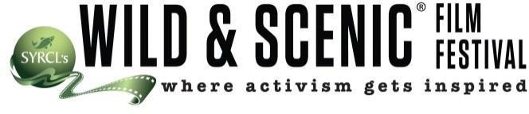
PRESS RELEASE

Your Logo HERE
For More Information:
Your contact info

A CELEBRATION OF OUR ENVIRONMENT!
The Wild & Scenic Film Festival virtually comes to <city name> <CITY, STATE>: For the last <# years> <HOST ORG> welcomed you to <City Name> for Wild & Scenic Film Festival. This year things are different, so we are bringing the festival to you! Join <HOST ORGANIZATION> to watch Wild and Scenic Film Festival On Tour from the comfort and safety of your home LIVE at <URL> on <DATE AND TIME>.

Held each January in Nevada City, California, the Wild & Scenic Film Festival celebrates the beauty and wonder of our natural world, and inspires audiences everywhere to take action to protect it. A fundraiser for SYRCL (the South Yuba River Citizen’s League), proceeds from the flagship festival each year go directly to fostering the science, advocacy, activism and education that are crucial to keeping the river healthy and beautiful. [optional: for fundraisers] Concerned citizens worldwide know the urgency of the many environmental crises facing our planet today, but most don’t know how they can contribute to the fight. Now, attendees in <CITY> can support their own local advocates for the environment by attending <HOST ORGANIZATION>’s Wild & Scenic Film Festival On Tour event.

The Wild & Scenic Film Festival was started by the watershed advocacy group, the South Yuba River Citizens League (SYRCL) in 2003. The festival’s namesake is in celebration of SYRCL’s landmark victory to receive “Wild & Scenic” status for 39 miles of the South Yuba River in 1999. The 5-day event features over 150 award-winning films and welcomes over 100 guest speakers, celebrities, and activists who bring a human face to the environmental movement. The home festival kicks-off the international tour to communities around the globe, allowing SYRCL to share their success as an environmental group with other organizations. The festival is building a network of grassroots organizations connected by a common goal of using film to inspire activism. With the support of National Partners: Peak Design, Hipcamp, EarthJustice, Klean Kanteen, and Sierra Nevada Brewing Company, the festival can reach an even larger audience.

<<”request a testimonial from WSFF staff member or a veteran WSFF Host at your organization”>>

Featured at the tour event in <CITY>, <SHARE A BRIEF OVERVIEW OF 2-3 FILMS FROM YOUR FILM
PROGRAM (USE FILM BIOS FOR IDEAS)>. The festival is a natural extension of <HOST ORGANIZATION>’s work to inspire people to act on behalf of the environment. <TAKE THIS OPPORTUNITY TO TALK ABOUT YOUR ORGANIZATION, CAMPAIGNS, AND WHY YOU ARE HOSTING THE FESTIVAL.>

EVENT DETAILS:
Date and Time: Doors open at XXpm and shows start at XXpm.
Ticket Prices:

Tickets can be purchased at www.XXXX.org. The box office is open XXX. For more information: Contact XXX, xxx@.org, 555-555-5555. www.xxx.org

