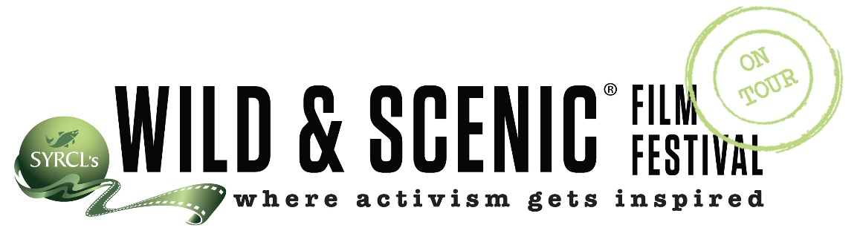

Visionary  Title Sponsor  $5000 | Named as Title Sponsor  Featured on ALL Promotional Materials | Only 3 Sponsors at This Level | Event Program:  Full Page Ad  Naming Title  2 Logo Placements | Tabling Space Provided  Banner Space  On stage Mention | Social Media  All Event Emails  Film Program Slide  Local & National Websites | 6 Tickets  Food & Drinks Provided  Reserved Seating
Catalyst  Films Sponsor  $3000 | Choose a Film to Sponsor  “This film brought to you by…” | 5-7 Sponsors  At This Level | Event Program:  ½ Page Ad  Thank You Mention | Tabling Space Provided  Banner Space | Social Media  All Event Emails  Logo Added to Bulk Sponsor Slide | 6 Tickets  Food & Drinks Provided  Reserved Seating
Leader  $1500 | Listed as Sponsor |  | Event Program  ¼ Page Ad | Tabling Space Provided | Social Media  All Event Emails  Sponsor List | 6 Tickets  Reserved Seating
Organizer  $500 | Listed as Sponsor |  | Event Program  1/8 Page Ad |  | All Event Emails  Sponsor List | 4 Tickets  Reserved Seating
Supporter  $250 |  |  |  |  | All Sponsor Lists | 2 Tickets  Reserved Seating

Sponsoring a Wild & Scenic Film Festival On Tour Event provides a media reach both on local and national scales.

